Task Description: Create a virtual machine (VM) on Microsoft Azure/AWS, configure it within a resource group and ensure basic security measures are implemented.

From what I understood from the task description, I just created a VPC and add subnets to that

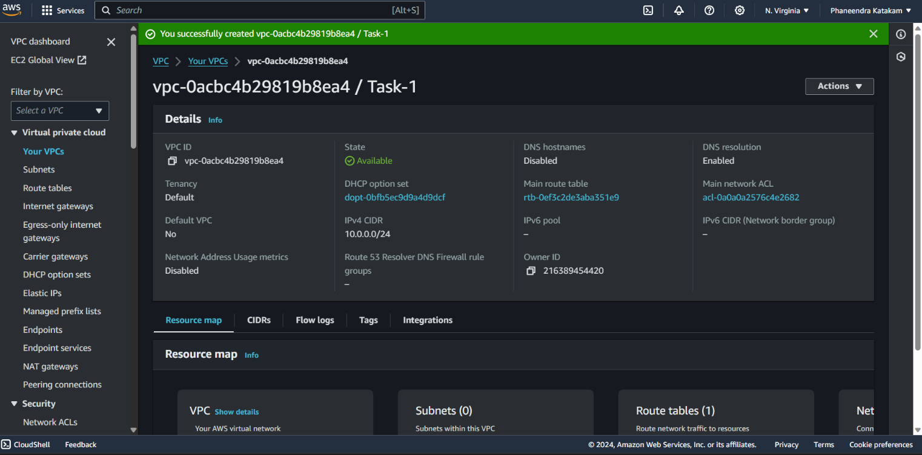

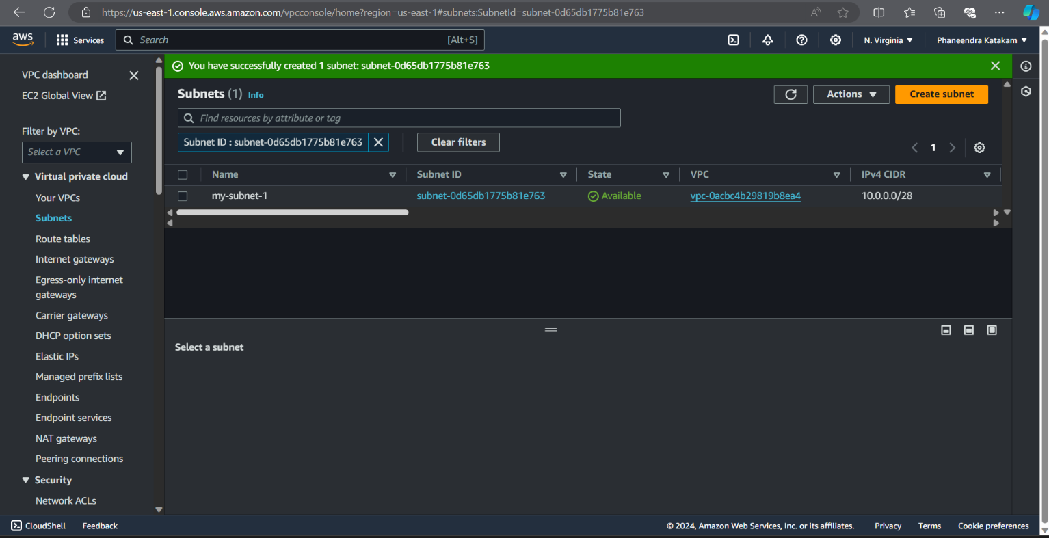

And in the next step I just created an EC2 instance and named it as “Task-1”

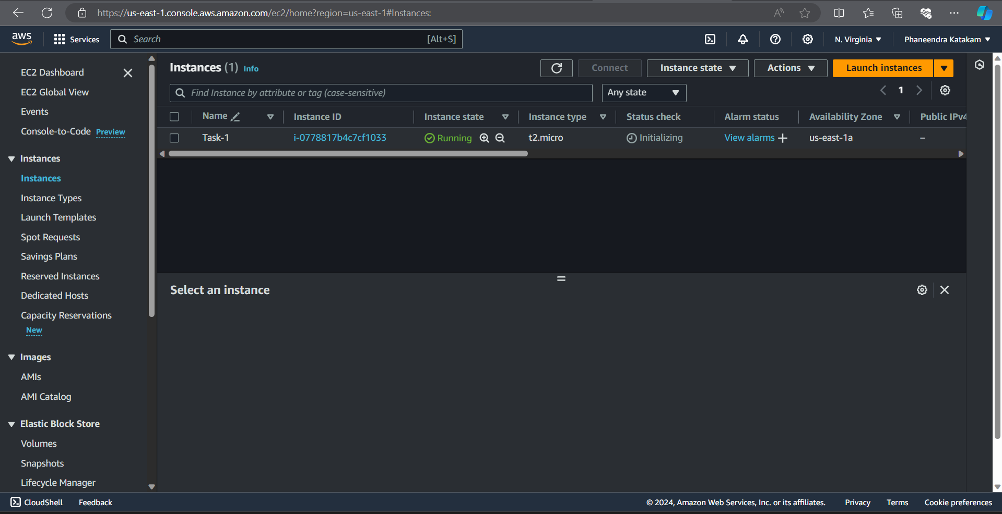

After that I created a resource group and named it as “Tasks”

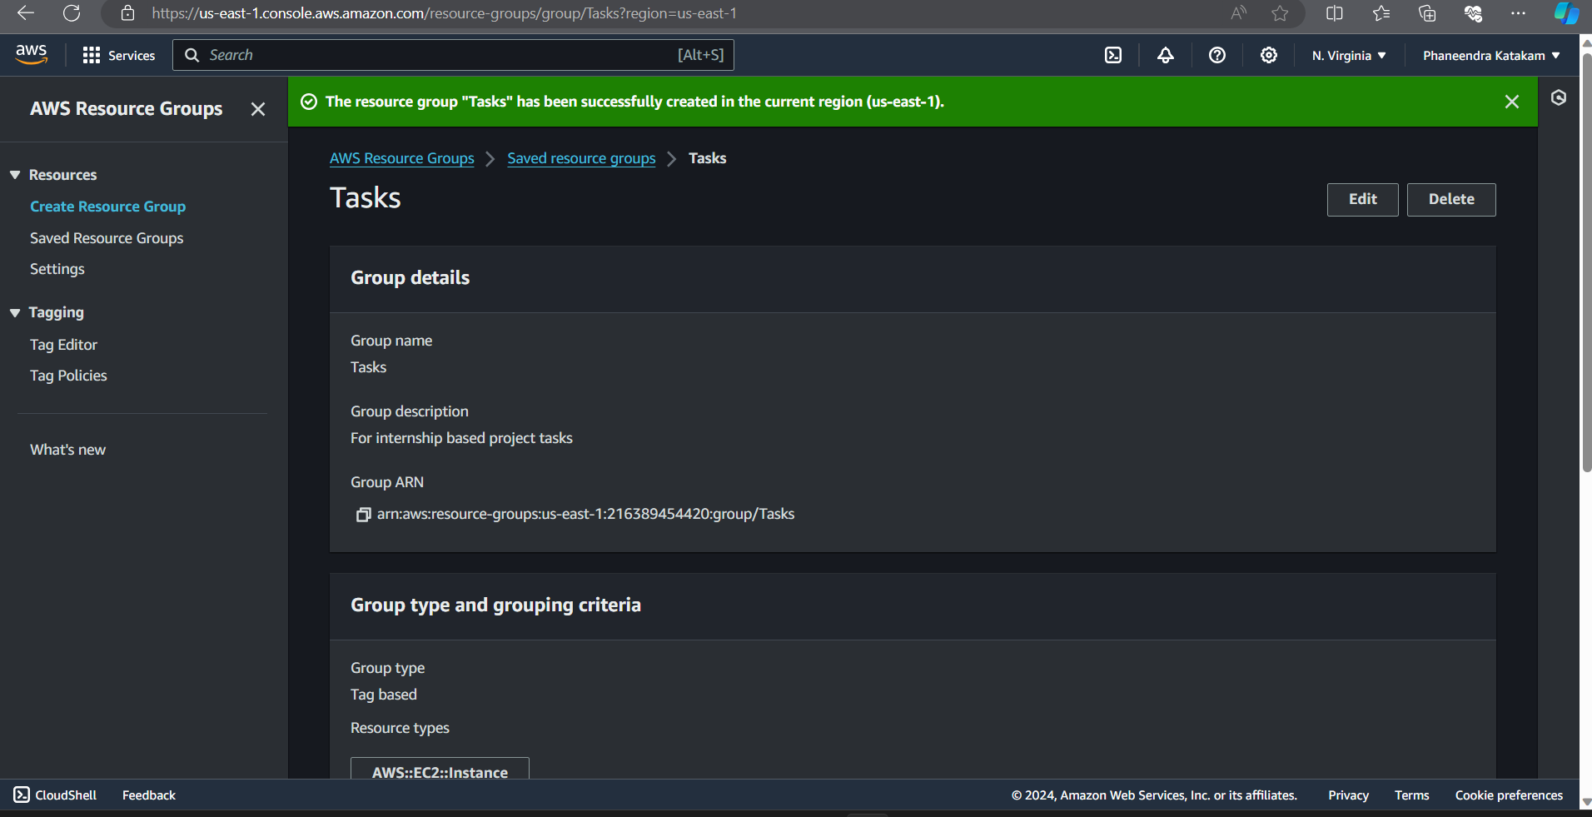

And here I configured the created instance into the resource group I created

